Penitas Plaza – Demographic Overview

1715 Highway 83, Penitas, TX 78576 | ZIP Code: 78576

# 📊 2023 Demographic Highlights

* 🧍 Population (2022): 6,340 (+443% since 2000)
* 📈 Median Age: 30.8 years (TX: 35.9)
* 👨 49.3% Male | 👩 50.7% Female
* 💰 Median Household Income: $54,252 (was $26,071 in 2000)
* 🧍 Per Capita Income: $18,406
* 🏠 Median Home Value: $213,509 (was $51,700 in 2000)
* 📊 Median Rent: $638/month
* 📉 Cost of Living Index: 81.5 (U.S. avg = 100)
* 🚨 Poverty Rate: 28.3%

*Source: City-Data.com – Penitas, TX (2023 estimates)

# 📈 Visual Charts

Gender Distribution:

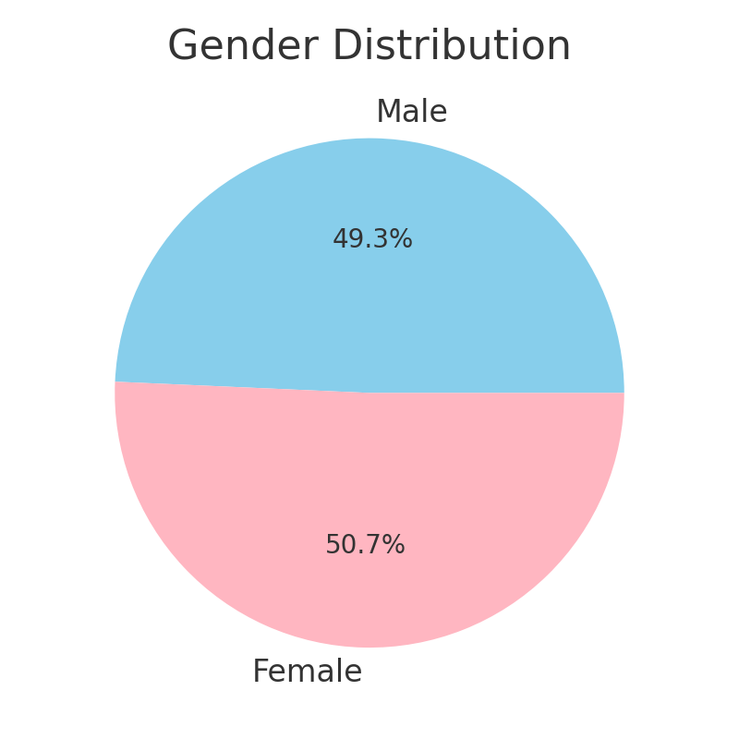

Median Household Income Comparison:

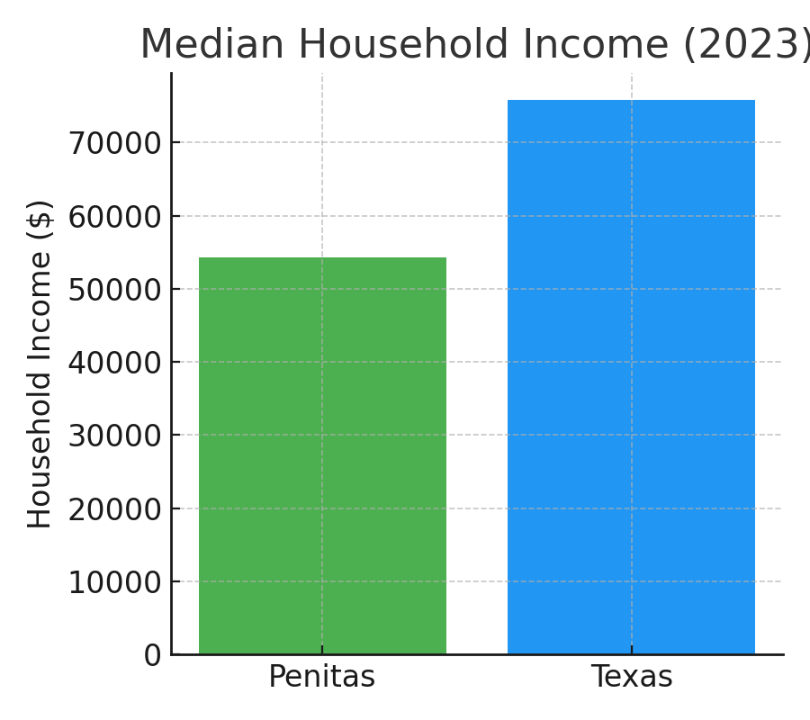

Median Home Value Comparison:

